About the speaker:
Zenab Sallam

Certified Six Sigma Black Belt & KATA 2nd Coach.
Holds a bachelor of Economics & Political Science.
Responsible for Lean Six Sigma Deployment
Leoni Wiring Systems, Egypt With 11 years experience in Continuous Improvement
Process Excellence
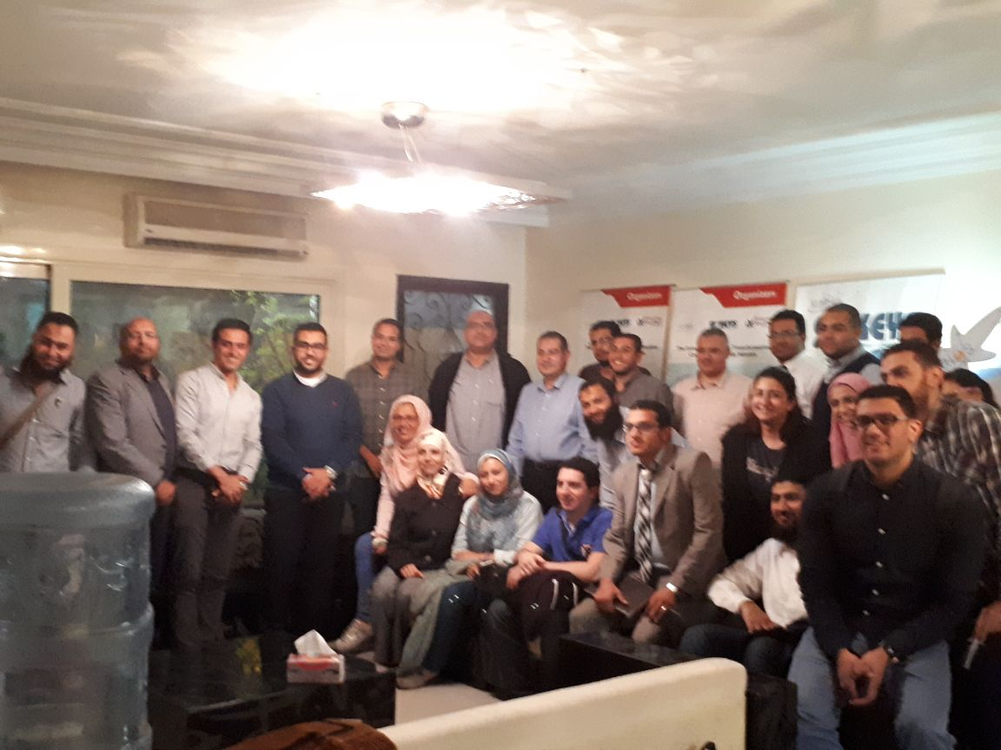
A lot of people have been wondering about how Leoni managed to implement the Kata tool successfully in their factories. Now the main target for most of the corporations is achieving KPIs, no matter how that will affect the employees and how stressful that can be and how it will affect their performance on the long term.

Leoni team chosen Zenab Sallam to share the success story of Leoni implementing the Kata and explaining how the Kata tool is used to achieve continuous improvement.

LEONI started the KATA deployment mid-2014, as a tool to create a sustained culture of continuous improvement.

